1 | Is there any inconsistency in the UI?    (buttons disabled)  Incorrect use of the cursor;
2 | Is there any inconsistency in the UI?  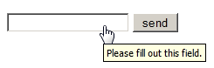  incorrect use of the cursor ;  we should write Send from the capital letter;
3 | Is there any inconsistency in the UI?  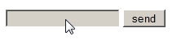  we should write Send from the capital letter
4 | How checkbox can be checked off?  By using mouse or keyboard;
5 | The gender selection is implemented on screen below. Please describe the weak points of this implementation and propose better way of implementation.  Should be 2 radio buttons;
6 | Please, propose improvements for the part of the screen below.  Requirement: if ‘no thanks’ checkbox is checked off other fields should be disabled  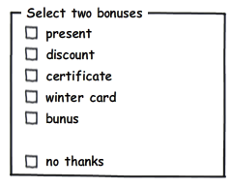  “no thanks” can’t be checkbox- we can use a radio button;
7 | Please provide your recommendations regarding improvements of the part of screen below.  Should be 2 buttons  or 2 radiobuttons;
8 | Would a radio button be a better choice? (select between Portrait and Landscape mode, Portrait uses by default )    We should use 2 radio buttons;
9 | Is radio button the best choice?  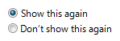  There should be one checkbox for “Don’t show this again”; So the user can mark if he/she wants or not to show it again;
10 | Is it the best implementation of the part of screen?  Should be placed vertically,  under each other;
11 | What is mixed-state for checkbox?  Interminated
12 | Can we use checkboxes as a progress indicator?  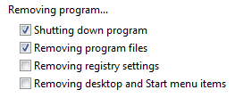  No, we should use a progress bar;
13 | Can we use the selection of a checkbox to perform commands?  No, we should use buttons;
14 | Can we use the selection of a checkbox to dynamically display other controls related to the selected control (screen readers cannot detect such events)? No
15 | Can we use the selection of a checkbox to display other windows, such as a dialog box to gather more input?  No
16 | Are there any inconsistency in the relationship between radio buttons and checkboxes?  Requirement: when ‘Custom’ radio-button is selected all checkboxes are enabled.  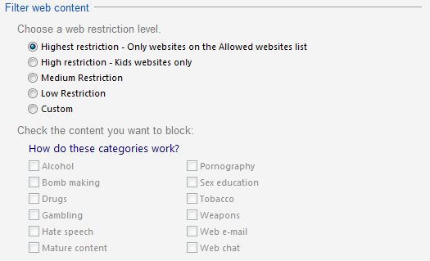  Due to the level of restriction, the categories which belong to this level should be marked automatically (the categories should be disabled , but marked);
17 | Is it the best implementation of screen?  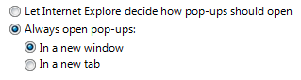  There should be 2 options:  - Always open pop-ups in a new window;  - Always open pop-ups in a new tab;
18 | How implementation of screen can be improved?  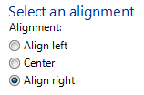  Drop down list should be used;
19 | Is it the best way of the controls’ location on the screen?    Should be placed vertically,  under each other;
20 | Is it right to leave editable text boxes and drop-down lists enabled if they share the radio button's label? (See example). What requirement should be for the editable field?  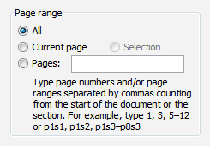  Correct
21 | What is list-box, drop-down list, combobox? What are the two types of combobox?  List box - a graphical control element that allows the user to select one or more items from a list contained within a static, multiple line text box.  Drop-down list - a graphical control element that allows the user to choose one value from a list.  Combo box - it is a combination of a drop-down list or list box and a single-line editable textbox, allowing the user to either type a value directly or select a value from the list.
22 | There are numbers from 1 to 31 (day of month) in dropdown list. How we can select 5?  By using mouse: click to open a list, scroll till 5, click on the number 5.  By using keyboard:  - Tab to the field that has the dropdown list.  - Use the up or down arrows to navigate to the selection you want.  - Press Enter to close the list and save the selection.  By using keyboard and mouse:  CTRL + Mouse Left Click to select a few items  SHIFT + Mouse Left Click to choose all the options or select a list of a group of options
23 | There are numbers from 1 to 31 (day of month) in dropdown list. How we can change selection between 3, 30, 31 items?  Hold down the control (ctrl) button to select multiple options.  (by clicking the mouse select and deselect an item)

